ONLINE BOOKSTORE MANAGEMENT SYSTEM — DETAILED DOCUMENTATION REPORT
(Using FastAPI (Python), JavaScript, CSS, Python, and Docker)

1. Title Page
Project Title: Web-Based Bookstore Management System Running on Docker
Submitted by: [Your Name]
Program: Bachelor in Computer Application / IT
Supervisor: [Supervisor Name]
Date: [Insert Date]
College / University: [Swastik College (TU)]

2. Abstract
This project presents a web-based Bookstore Management System developed using FastAPI (Python), JavaScript, CSS, and Python, and deployed via Docker containers to ensure portability, scalability, and simplified environment setup. Traditional book management practices are mostly manual, leading to errors, slow billing, and inefficient stock management. The objective of this project is to automate bookstore operations such as book inventory management, customer handling, order processing, reporting, and real-time updates.
The system follows modular architecture with separate services for frontend, backend, database, and analytics, each containerized using Docker. The Python component provides automated report generation and sales analysis. The project demonstrates how containerization enhances consistency between development and production environments. The results show improved accuracy, faster processing, and enhanced usability, making the solution suitable for small to medium-sized bookstores.

3. Introduction
A bookstore requires efficient management of books, customers, sales, billing, and stock. Manual workflows are slow and error-prone. A digital management system allows real-time tracking, efficient updates, and improved customer experience.
This project develops a full-stack bookstore system deployed on Docker, enabling reliable, consistent operation across all devices. Docker ensures that the application runs the same way on every machine, reducing dependency errors and compatibility issues.

3.1 Scope of the Project
The project includes:
- Online book catalog
- Admin dashboard
- Inventory management
- Customer registration and login
- Shopping cart and order processing
- Search and filtering (JavaScript)
- Python-based analytics (sales reports)
- Docker container deployment (FastAPI (Python)–Apache, MySQL, Python script)

4. Problem Statement
Traditional bookstore systems rely on manual record-keeping, resulting in:
- Difficulty tracking stock levels
- Human errors in billing
- No quick search/filtering
- No automated reporting
- Hard to maintain records
Thus, a digital system is needed for speed, accuracy, and simplified operations.

5. Objectives
Main Objective
To develop and deploy a containerized web-based Bookstore Management System using FastAPI (Python), JS, CSS, Python, and Docker.
Specific Objectives
- Implement book inventory CRUD function.
- Provide customer registration and login.
- Add cart and order processing.
- Provide admin dashboard with analytics.
- Use Python for sales reporting.
- Containerize the application using Docker for easy deployment.
- Use MySQL as the database inside a Docker container.

6. Literature Review
Brief review should include:
- Existing bookstore/e-commerce web applications
- Use of FastAPI (Python) in server-side web development
- Use of JavaScript for dynamic UI interactions
- CSS for responsive design
- Python for data analytics in web systems
- Docker as modern DevOps tool for deployment
Example systems reviewed:
System/Technology | Key Features | Limitations
Local Bookstore POS | Fast billing | No online access
Amazon Books | Recommendation engine | Complex system
Traditional PHP bookstore apps | Easy to deploy | Hard to scale
Docker-based deployments | Fast & portable | Requires DevOps knowledge

7. System Requirements
  - Hardware Requirements
- Intel i5 or above
- 8 GB RAM
- 40 GB storage
  - Software Requirements
- Docker Desktop
- FastAPI (Python) 8.x
- Apache Web Server (via Docker image)
- MySQL 8.x
- Python 3.x
- VS Code
- Browser (Chrome)

8. System Analysis
8.1 Existing System
Manual system with:
- handwritten bills
- manual stock tracking
- no reporting
- error-prone
8.2 Proposed System
Fully automated website with:
- live inventory updates
- digital invoices
- order history
- analytics
8.3 Feasibility Study
- Technical Feasibility
The project is technically feasible because it uses FastAPI (Python), JavaScript, and Docker, all of which are widely supported, reliable, and easy for developers to work with. These technologies have strong documentation and community support, making implementation smooth and efficient.
- Economic Feasibility
This project is economically feasible since it requires very low cost. All the tools and platforms used are open-source and freely available, meaning there is no need for expensive licenses or hardware. This keeps the overall project budget minimal.
- Operational Feasibility
The system is operationally feasible because it is simple, user-friendly, and easy to operate. Users can interact with the system without needing advanced technical skills, and the workflow is designed to be smooth and efficient for daily use.
- Legal Feasibility
There are no legal issues involved as the project uses open-source tools that are free to use and distribute. All technologies comply with open-source licenses, ensuring the project does not violate any legal or copyright restrictions.
- Schedule Feasibility
The project is schedule-feasible because it can be fully completed within the academic timeline. The tasks, tools, and workload are manageable, allowing the project to be developed, tested, and finalized on time.

9. System Design
9.1 Use Case Diagram
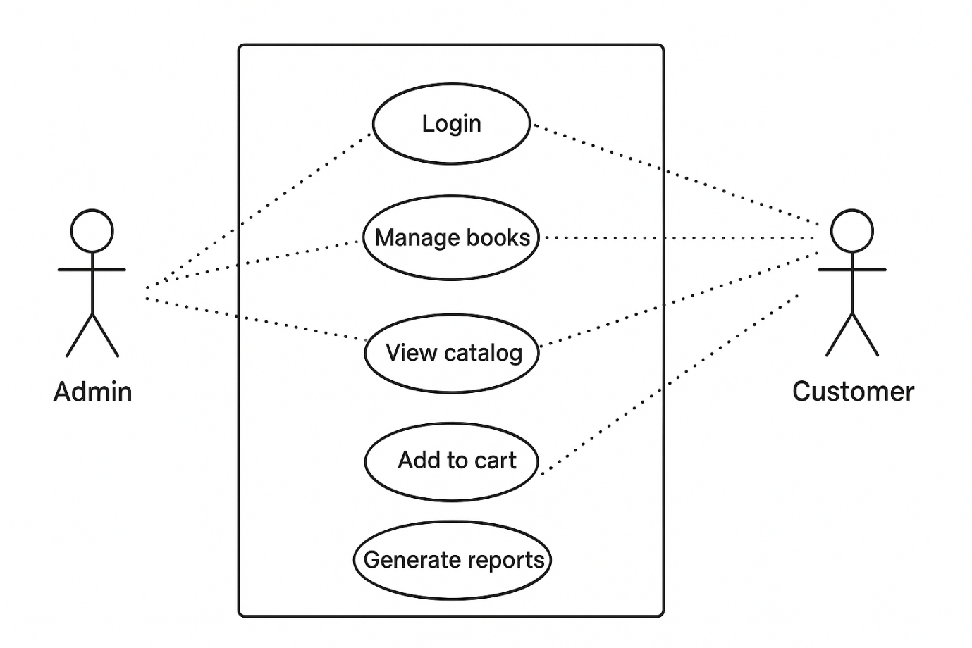
Actors
1. Admin
Admin is responsible for managing and maintaining the online bookstore system.
2. Customer
Customer is the end user who browses books and purchases them from the store.
Use Cases :
1. Login
- Actors: Admin, Customer
- Description:
Allows users to authenticate themselves by entering valid credentials.
- Purpose:
Ensures secure access to the system.

2. Manage Books
- Actor: Admin
- Description:
Admin can add new books, update book details, delete books, and manage stock.
- Purpose:
Keeps the book catalog updated and accurate.

3. View Catalog
- Actor: Customer
- Description:
Customer can browse available books by category, author, or title.
- Purpose:
Enables customers to explore books before purchasing.

4. Add to Cart
- Actor: Customer
- Description:
Customer selects books and adds them to the shopping cart.
- Purpose:
Helps customers prepare their order.

5. Checkout
- Actor: Customer
- Description:
Customer confirms the order, provides delivery details, and makes payment.
- Purpose:
Completes the purchase process.

6. Generate Reports
- Actor: Admin
- Description:
Admin generates sales reports, order summaries, and inventory reports.
- Purpose:
Helps in business analysis and decision-making.
9.2 ER Diagram
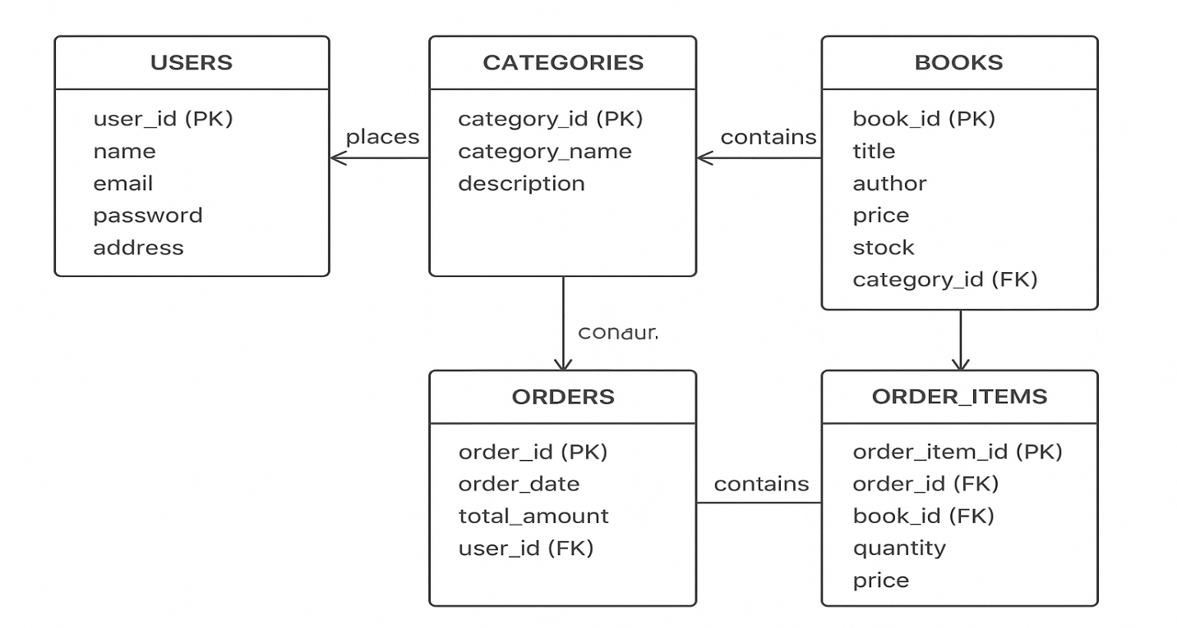
An Entity Relationship (ER) Diagram describes the data structure of the online bookstore by showing entities (tables), their attributes, and the relationships between them.
Tables:

1. Users Table
Purpose: Stores information about registered customers.
Key Attributes:
- user_id (PK) – Unique identifier for each user
- name
- email
- password
- address
Explanation:
Each user can place multiple orders, but every order belongs to only one user.

2. Books Table
Purpose: Stores details of books available in the bookstore.
Key Attributes:
- book_id (PK) – Unique identifier for each book
- title
- author
- price
- stock
- category_id (FK)
Explanation:
Each book belongs to one category and can be ordered multiple times by different users.

3. Categories Table
Purpose: Organizes books into different categories.
Key Attributes:
- category_id (PK) – Unique identifier
- category_name
- description
Explanation:
One category can contain many books, but each book belongs to only one category.

4. Orders Table
Purpose: Stores information about customer orders.
Key Attributes:
- order_id (PK) – Unique identifier
- order_date
- total_amount
- user_id (FK)
Explanation:
Each order is placed by a single user but can include multiple books.

5. Order_Items Table
Purpose: Acts as a junction (bridge) table between Orders and Books.
Key Attributes:
- order_item_id (PK)
- order_id (FK)
- book_id (FK)
- quantity
- price
Explanation:
This table resolves the many-to-many relationship between Orders and Books.
Each record represents a specific book included in a specific order.

- Users
- Books
- Orders
- Order_Items
- Categories
An Entity–Relationship (ER) diagram represents the data structure of the system, showing entities, their attributes, and relationships.

Entities and Their Descriptions
1. Users
Purpose: Stores information about customers using the bookstore.
Attributes:
- user_id (Primary Key)
- name
- email
- password
- address
Explanation:
Each user can place multiple orders, but each order belongs to one user.

2. Books
Purpose: Stores details of books available for sale.
Attributes:
- book_id (Primary Key)
- title
- author
- price
- stock
- category_id (Foreign Key)
Explanation:
Each book belongs to one category and can appear in many orders.

3. Categories
Purpose: Classifies books into different groups.
Attributes:
- category_id (Primary Key)
- category_name
- description
Explanation:
A category can contain many books, but each book belongs to only one category.

4. Orders
Purpose: Stores customer order details.
Attributes:
- order_id (Primary Key)
- order_date
- total_amount
- user_id (Foreign Key)
Explanation:
Each order is placed by one user and can include multiple books.

5. Order_Items
Purpose: Resolves the many-to-many relationship between Orders and Books.
Attributes:
- order_item_id (Primary Key)
- order_id (Foreign Key)
- book_id (Foreign Key)
- quantity
- price
Explanation:
Each record represents one book in a specific order.

Relationships Between Entities
1. Users → Orders
- Relationship: One-to-Many (1:N)
- Meaning: One user can place many orders.

2. Orders → Order_Items
- Relationship: One-to-Many (1:N)
- Meaning: One order can have multiple order items.

3. Books → Order_Items
- Relationship: One-to-Many (1:N)
- Meaning: One book can appear in many order items.

4. Categories → Books
- Relationship: One-to-Many (1:N)
- Meaning: One category contains multiple books.

9.3 Data Flow Diagram
A Data Flow Diagram (DFD) shows how data moves through a system, the processes that transform data, data stores, and external entities.
Level 0 DFD (Context Diagram)
Description:
Level 0 DFD represents the entire online bookstore as a single process interacting with external entities.
Components:
Process:
- Online Bookstore System
External Entities:
- Customer
- Admin

Data Flows:
- Customer → Bookstore: Search request, order details, payment information
- Bookstore → Customer: Book details, order confirmation
- Admin → Bookstore: Book updates, report requests
- Bookstore → Admin: Sales reports, inventory reports
Purpose:
Provides a high-level overview of how the system interacts with users.

Level 1 DFD (Major Functional Modules)
Level 1 DFD breaks the system into main subprocesses.
Processes:
1. Book Management
Handled by: Admin
Functions:
- Add new books
- Update book details
- Delete books
- Manage categories and stock
Data Store Used:
- Books Database

2. Order Processing
Handled by: Customer
Functions:
- View catalog
- Add books to cart
- Checkout
- Payment processing
- Order confirmation
Data Stores Used:
- Users
- Orders
- Order_Items

3. Analytics
Handled by: Admin
Functions:
- Generate sales reports
- View order history
- Analyze popular books
Data Stores Used:
- Orders
- Order_Items
- Books

Purpose of Level 1:
Shows how the bookstore system is divided into core functional areas.

Level 2 DFD (Detailed Process Breakdown)
Level 2 DFD provides detailed internal working of Level 1 processes.

Level 2 DFD – Book Management
Sub-processes:
- Add Book
- Update Book
- Delete Book
- Manage Categories
Data Flow:
- Admin → Book Details → Book Management
- Book Management → Books Database (store/update/delete data)

Level 2 DFD – Order Processing
Sub-processes:
- Search Books
- Add to Cart
- Checkout
- Payment Processing
- Order Confirmation
Data Flow:
- Customer → Search Request → Search Books
- Books Database → Book List → Customer
- Cart Details → Checkout
- Payment Info → Payment Gateway
- Order Details → Orders Database
- Confirmation → Customer

Level 2 DFD – Analytics
Sub-processes:
- Collect Order Data
- Analyze Sales
- Generate Reports
Data Flow:
- Orders & Order_Items → Analytics
- Analytics → Sales Reports
- Reports → Admin

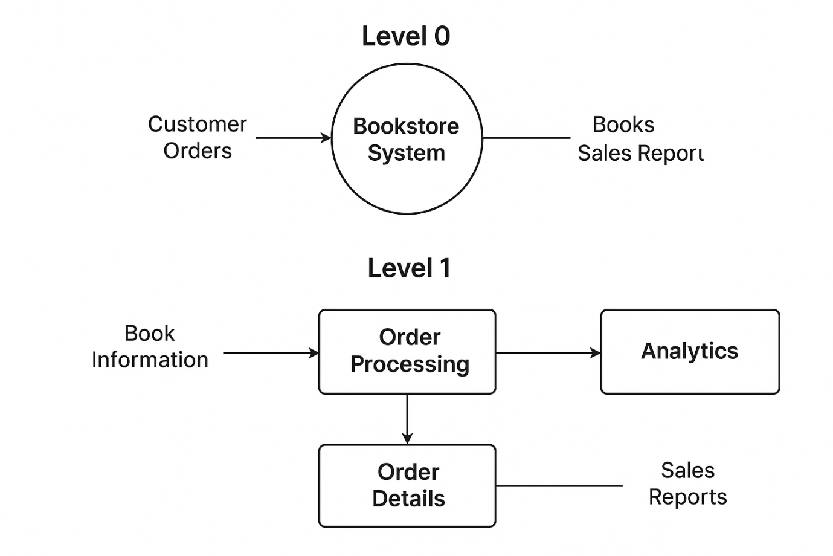
Level 2 DFD diagram
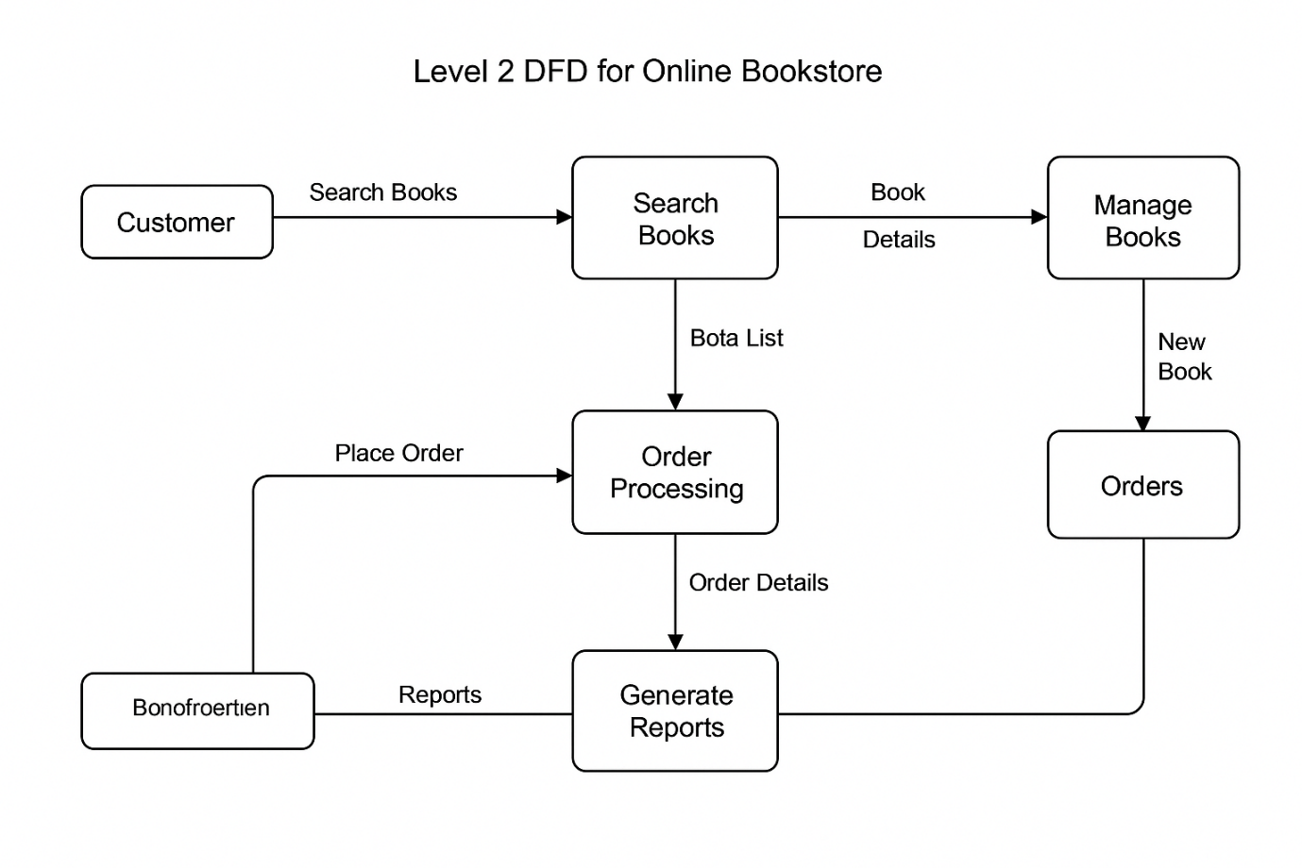

9.4 UI Layout
Pages:
- Login page
- Admin dashboard
- Book list
- Book details
- Cart
- Checkout
- Reports

10. Technologies Used
  - FastAPI (Python)
- Backend logic
- Connects to MySQL
- CRUD operations
  - JavaScript
- Cart updates
- Form validation
- Live book search/filter
  - CSS
- Responsive layout
- Grid/flexbox design
  - Python
- Sales reporting Inventory prediction (optional)
10.5 Docker
Containers used:
- FastAPI (Python)-Apache container
- MySQL container
- Python analytics container
Docker makes deployment consistent and repeatable.

11. Docker Setup
11.1 docker-compose.yml (sample)
version: '3.8'
services:
web:
image: php:8.2-apache
container_name: bookstore_php
volumes:
- ./php:/var/www/html/
ports:
- "8080:80"
depends_on:
- db

db:
image: mysql:8.0
container_name: bookstore_db
environment:
MYSQL_ROOT_PASSWORD: root
MYSQL_DATABASE: bookstore
volumes:
- ./db:/var/lib/mysql
ports:
- "3306:3306"

analytics:
build: ./python
container_name: bookstore_python
volumes:
- ./python:/app
depends_on:
- db

12. Implementation
[Frontend Home Page Implementation]
Include small code snippets.
FastAPI (Python) Login Example
<?php
session_start();
include 'db.php';

if(isset($_POST['login'])){
$email = $_POST['email'];
$pass = $_POST['password'];

$query = "SELECT * FROM users WHERE email='$email' AND password='$pass'";
$result = mysqli_query($conn, $query);

if(mysqli_num_rows($result) == 1){
$_SESSION['user'] = $email;
header("Location: dashboard.php");
} else {
echo "Invalid credentials!";
}
}
?>

JavaScript Cart Example
function addToCart(id) {
let cart = JSON.parse(localStorage.getItem("cart")) || [];
cart.push({ book_id: id });
localStorage.setItem("cart", JSON.stringify(cart));
alert("Book added to cart!");
}

Python Report Generator
import mysql.connector
import pandas as pd

db = mysql.connector.connect(
host="db",
user="root",
password="root",
database="bookstore"
)

query = "SELECT * FROM orders"
df = pd.read_sql(query, db)
df.to_csv("/app/sales_report.csv")

13. Testing
[Checkout Process Testing]
Types of Testing
- Unit testing
Tests individual functions such as login validation, cart total calculation, and search functionality.
Test Case ID | Module | Test Description | Input | Expected Output | Actual Result | Status
UT-01 | User Login | Verify login with valid credentials | Valid email & password | User logged in successfully | As expected | Pass ✅
UT-02 | User Login | Verify login with invalid credentials | Wrong password | Error message displayed | As expected | Pass ✅
UT-03 | Book Search | Search book by title | “Software Engineering” | Relevant books listed | As expected | Pass ✅
UT-04 | Book Details | View book details page | Book ID | Book info displayed | As expected | Pass ✅
UT-05 | Add to Cart | Add book to cart | Book ID, quantity = 1 | Book added to cart | As expected | Pass ✅
UT-06 | Cart Management | Update quantity in cart | Quantity = 2 | Quantity updated | As expected | Pass ✅
UT-07 | Checkout | Proceed to checkout | Cart items | Redirect to payment page | As expected | Pass ✅
UT-08 | Payment | Make payment with valid details | Valid card info | Payment successful | As expected | Pass ✅
UT-09 | Order Processing | Generate order after payment | Payment success | Order ID generated | As expected | Pass ✅
UT-10 | Logout | Logout from system | Click logout | User logged out | As expected | Pass ✅

- Integration testing
Tests interaction between modules like cart, order processing, payment, and notification systems.
Test Case ID | Integrated Modules | Test Scenario | Input | Expected Outcome | Status
IT-01 | User Registration ↔ Database | Verify user data saved after registration | User details | User record stored in DB | Pass ✅
IT-02 | Login ↔ Authentication ↔ Database | Verify login with stored credentials | Valid email & password | Successful login | Pass ✅
IT-03 | Search ↔ Book Catalog ↔ Database | Search book retrieves correct data | Book title/author | Matching books displayed | Pass ✅
IT-04 | Book Details ↔ Inventory | Verify stock availability shown correctly | Book ID | Correct stock count displayed | Pass ✅
IT-05 | Add to Cart ↔ Cart ↔ Inventory | Add item updates cart and reduces stock | Book ID, quantity | Cart updated, inventory reduced | Pass ✅
IT-06 | Cart ↔ Pricing ↔ Discount Module | Verify price calculation with discount | Coupon code | Correct total price shown | Pass ✅
IT-07 | Checkout ↔ Order Management | Verify order creation after checkout | Cart items | Order record created | Pass ✅
IT-08 | Order Management ↔ Payment Gateway | Verify payment transaction and order confirmation | Valid payment details | Payment success, order confirmed | Pass ✅
IT-09 | Payment ↔ Notification Service | Verify email/SMS sent after successful payment | Payment success | Confirmation notification sent | Pass ✅
IT-10 | Order ↔ Shipping Module | Verify shipping details passed correctly | Delivery address | Shipping initiated | Pass ✅
IT-11 | Order ↔ Inventory | Verify stock updated after order completion | Order confirmation | Inventory reduced correctly | Pass ✅
IT-12 | Admin Panel ↔ Reports ↔ Database | Verify sales report generation | Date range | Accurate report generated | Pass ✅

- UI testing
Checks user interface elements such as buttons, forms, navigation, and responsiveness.
Test ID | UI Screen / Page | Test Case Description | Expected Result
UI-01 | Home Page | Verify home page loads properly | Page loads without errors
UI-02 | Home Page | Check logo, menu, and search bar visibility | All UI elements visible and aligned
UI-03 | Login Page | Verify input fields and buttons | Fields accept input, buttons clickable
UI-04 | Login Page | Display error message for invalid login | Proper error message shown
UI-05 | Book Listing Page | Verify book images, title, price, and rating | All book details displayed correctly
UI-06 | Book Details Page | Verify “Add to Cart” button | Button visible and enabled
UI-07 | Cart Page | Verify cart layout and item details | Items, quantity, price shown correctly
UI-08 | Cart Page | Update quantity using UI controls | Quantity updates correctly
UI-09 | Checkout Page | Verify address and payment UI fields | All fields visible and usable
UI-10 | Payment Page | Validate error messages for empty/invalid fields | User-friendly error shown
UI-11 | Order Confirmation | Verify confirmation message and order ID | Order details displayed clearly
UI-12 | Responsive UI | Check UI on mobile/tablet/desktop | Layout adjusts correctly

- Black-box testing
Validates system functionality without knowing internal code, focusing on inputs and outputs.
Test ID | Feature / Module | Test Case Description | Input | Expected Output
BB-01 | User Registration | Register with valid details | Valid name, email, password | Registration successful
BB-02 | User Registration | Register with invalid email | Invalid email format | Error message shown
BB-03 | Login | Login with valid credentials | Valid email & password | User logged in
BB-04 | Login | Login with wrong password | Incorrect password | Error message displayed
BB-05 | Book Search | Search book by title | “Database Systems” | Relevant books listed
BB-06 | Book Search | Search with no matching book | Random keyword | “No results found” message
BB-07 | Add to Cart | Add available book to cart | Book ID, quantity = 1 | Book added to cart
BB-08 | Add to Cart | Add book with quantity more than stock | Quantity > stock | Stock warning shown
BB-09 | Checkout | Checkout with valid cart items | Cart items | Redirect to payment page
BB-10 | Payment | Make payment with valid details | Valid card info | Payment successful
BB-11 | Payment | Make payment with invalid details | Invalid card number | Payment failed message
BB-12 | Order Confirmation | View order confirmation after payment | Successful payment | Order ID and details displayed

- Database testing
Ensures correct data storage, retrieval, integrity, and relationships between tables.
Test ID | Database Area | Test Case Description | Test Data / Action | Expected Result
DB-01 | User Table | Insert new user record | Valid user details | Record inserted successfully
DB-02 | User Table | Validate unique email constraint | Duplicate email | Insert rejected
DB-03 | User Table | Verify password stored securely | User registration | Password encrypted/hashed
DB-04 | Book Table | Retrieve book details | Select by Book ID | Correct book data returned
DB-05 | Book Table | Check book price and stock accuracy | Query price & stock | Correct values shown
DB-06 | Cart Table | Insert item into cart | User ID, Book ID | Cart record created
DB-07 | Orders Table | Create order record after checkout | Successful checkout | Order stored with unique Order ID
DB-08 | Order_Items Table | Map books to orders | Order ID, Book IDs | Correct order-item mapping
DB-09 | Inventory Table | Update stock after order placement | Order confirmation | Stock reduced correctly
DB-10 | Payment Table | Store payment transaction details | Successful payment | Payment record saved
DB-11 | Referential Integrity | Verify foreign key relationship | Delete parent record | Related child records handled correctly
DB-12 | Backup & Recovery | Restore database from backup | Database failure simulation | Data recovered successfully

Sample Test Case
Test ID | Input | Expected Output | Result
TC-01 | Valid login | Dashboard opens | Pass
TC-02 | Add book | Book listed | Pass
TC-03 | Checkout | Order saved | Pass

14. Results & Discussion
The system successfully:
- Automates book inventory management
- Provides fast search & filtering
- Reduces billing time
- Generates sales reports using Python
- Runs consistently on any machine due to Docker
- Improves reliability and portability

15. Conclusion
The bookstore management system fulfills all required objectives and solves major limitations of traditional manual systems. Docker deployment ensures stability across environments, demonstrating how modern container technology can enhance web applications.

16. Future Enhancements
- Add mobile app
- Add online payment gateway
- AI-based book recommendation engine
- Multi-store support
- Cloud deployment (AWS, Azure)

17. References
The references listed below were used to design, develop, deploy, and analyze the online bookstore management system. Each reference contributed to a specific technical or conceptual aspect of the project.

1. Docker Documentation
Purpose:
Docker documentation was referred to for containerizing the online bookstore application.
Usage in Online Bookstore:
- Running the FastAPI (Python) backend, MySQL database, and Python analytics as separate containers
- Creating a Dockerfile and docker-compose.yml to manage services
Example:
- FastAPI (Python) application container for handling user login and orders
- MySQL container for storing users, books, and orders
- Python container for sales analytics
Benefit:
Ensures portability, easy deployment, and consistent environment across systems.

2. FastAPI (Python) Manual
Purpose:
The FastAPI (Python) manual was used for backend development of the online bookstore.
Usage in Online Bookstore:
- Handling user authentication (login, registration)
- Processing add-to-cart and checkout operations
- Communicating with the MySQL database
Example:
- Using PDO for secure database connections
- Form validation for login and checkout pages
Benefit:
Provides server-side logic and ensures secure and dynamic content handling.

3. MySQL Documentation
Purpose:
MySQL documentation guided the database design and management of the bookstore.
Usage in Online Bookstore:
- Designing tables: Users, Books, Orders, Order_Items, Categories
- Applying primary keys, foreign keys, and constraints
- Writing optimized SQL queries
Example:
- Retrieving order history of a customer
- Updating book stock after successful checkout
Benefit:
Ensures data integrity, reliability, and efficient data retrieval.

4. Python Pandas Library
Purpose:
Pandas library was used for data analysis and report generation.
Usage in Online Bookstore:
- Analyzing sales data
- Finding most purchased books
- Generating monthly sales reports
Example:
- Reading order data from MySQL into Pandas DataFrame
- Calculating total revenue and best-selling categories
Benefit:
Enables powerful data analytics and supports business decision-making.

5. Research Papers on Bookstore Management Systems
Purpose:
Research papers were reviewed to understand existing bookstore systems, best practices, and challenges.
Usage in Online Bookstore:
- Understanding system architecture
- Learning about inventory management techniques
- Studying security and scalability issues
Example:
- Adopting modular system design
- Improving user experience and performance
Benefit:
Helps in designing a robust, scalable, and efficient system.


[Admin Dashboard Implementation]
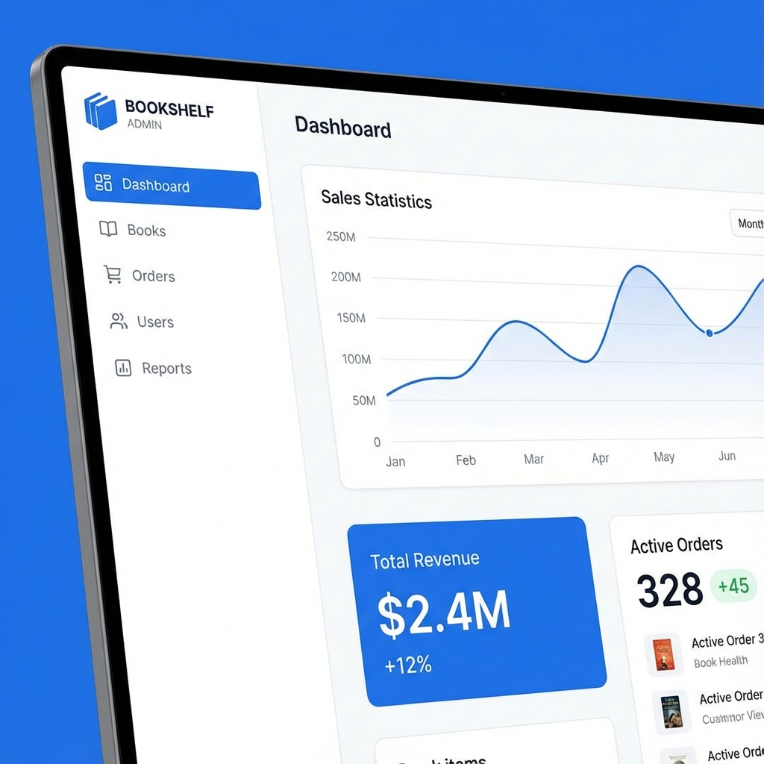
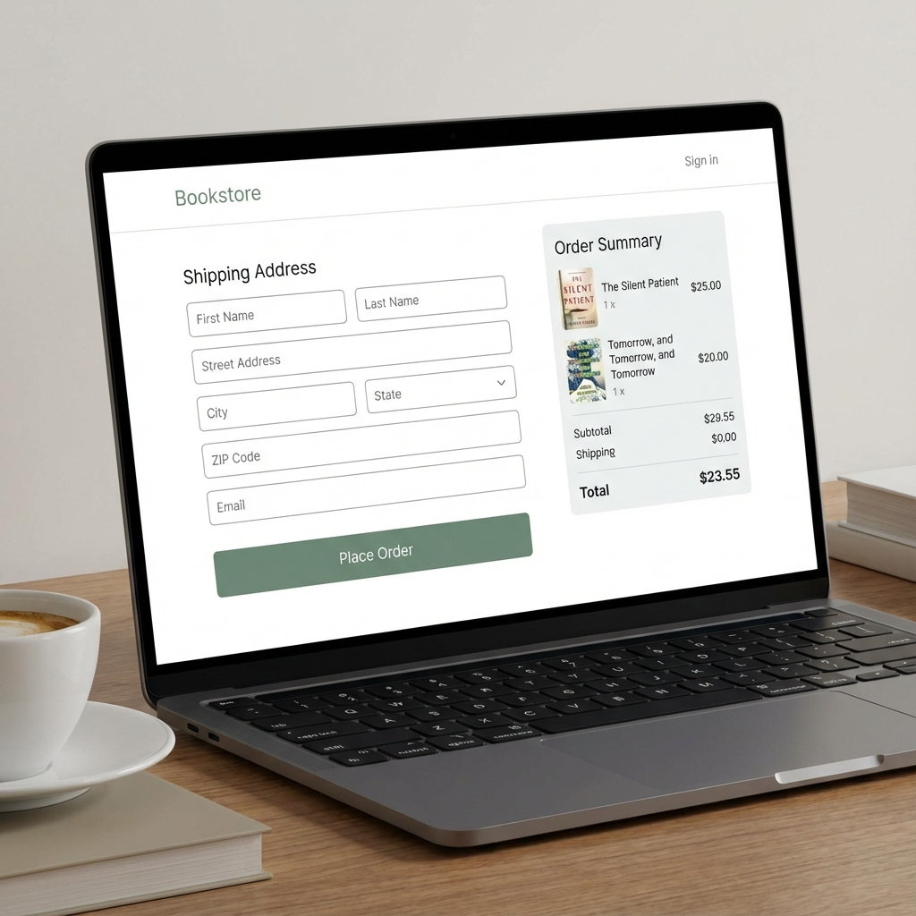
[Database Schema Verification]
